I
n this session we will try to understand what is decision table with HIT policy UNIQUE

Each row in a decision table is a rule. Hit policy "Unique" will typically make it easy to build a decision table which makes sure that your rules are "complete" - in the sense that the rules do not overlap but cover all possible input values - so that you do not "forget" anything.

Camunda DMN Decision Table HIT policy UNIQUE
It is an advantage that Unique hit policy makes your decision logic invalid in case you violate its requirement that your table rules never "overlap": after all you must not produce ambiguous results.

To demonstrate the user of HIT policy UNIQUE, We will model below process and decision table.

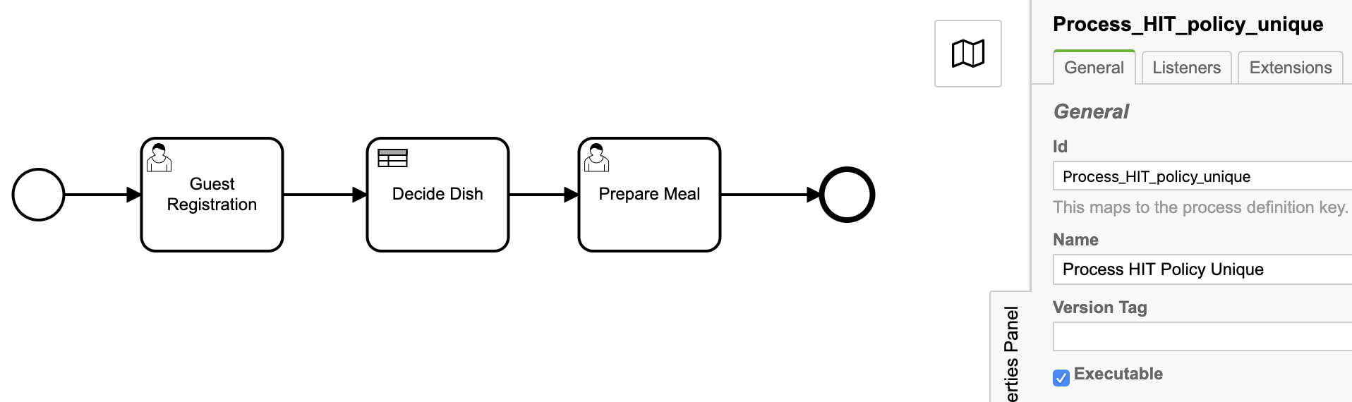
1. Process definition (BPMN)

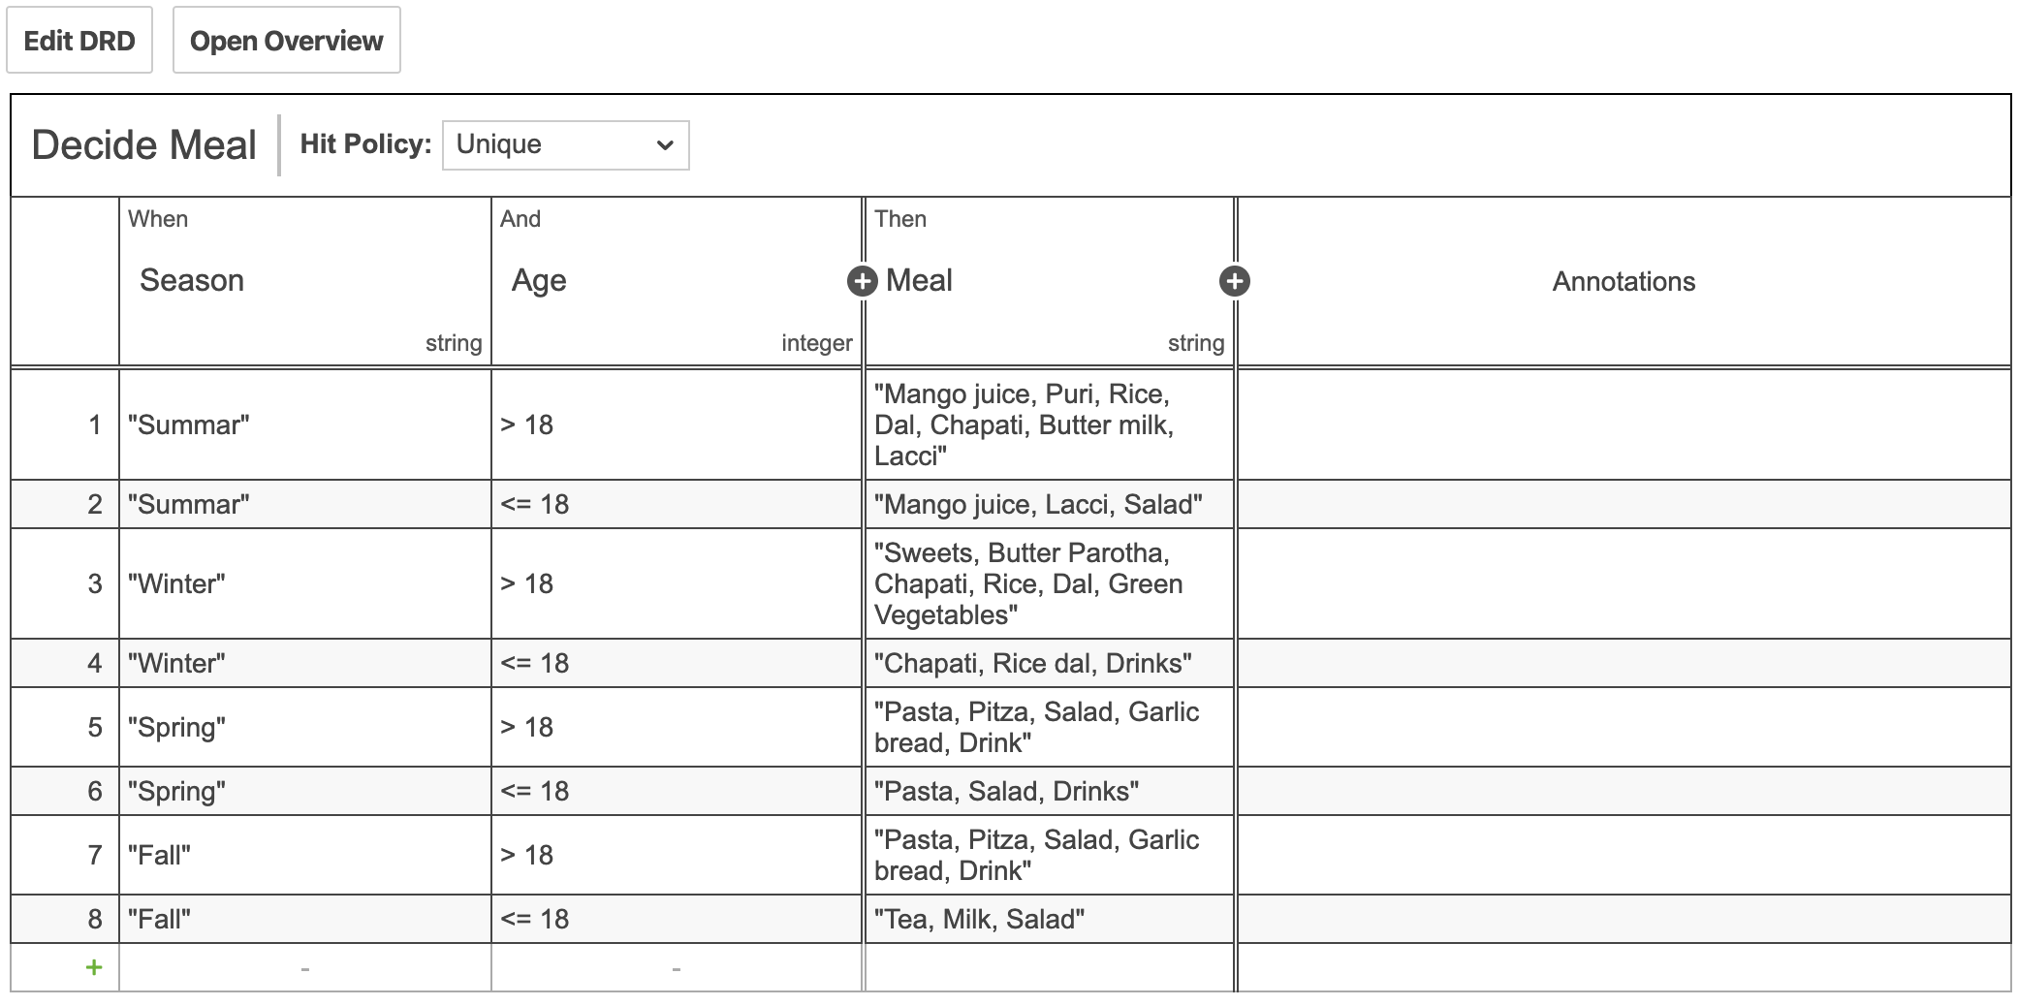
2. Decision table (DMN)
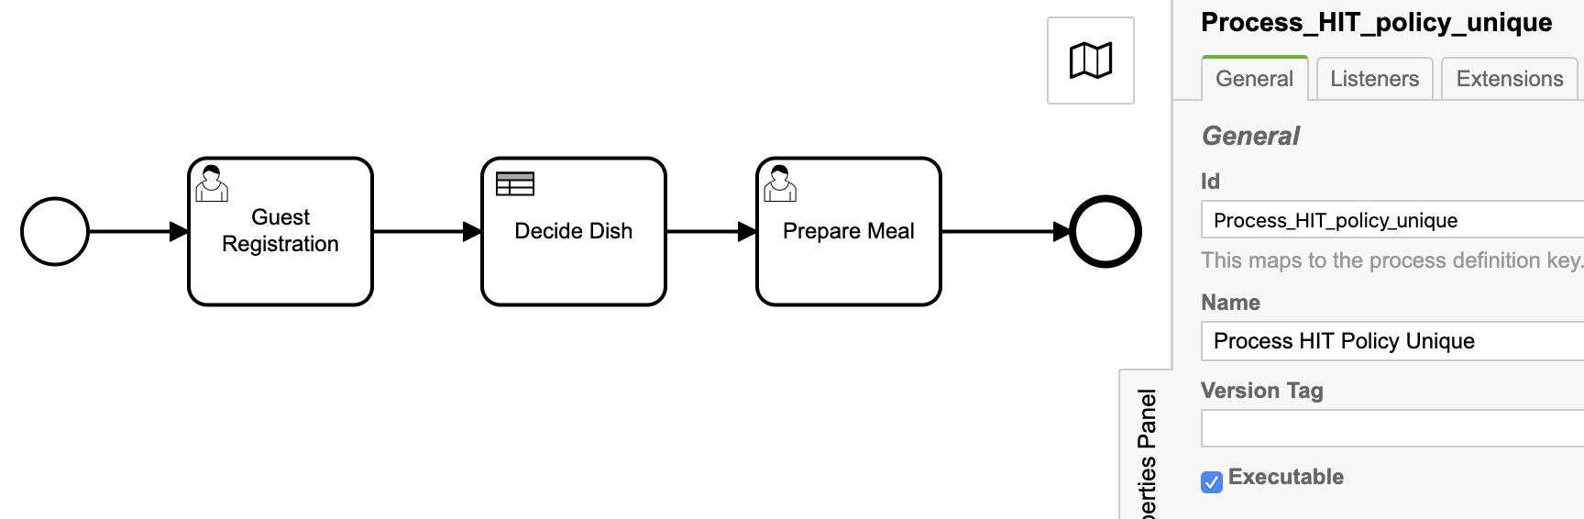
3. Process definition properties
Id: Process_HIT_policy_unique
Name: Process HIT Policy Unique

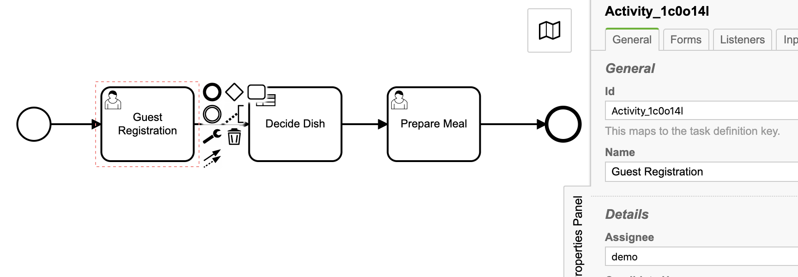
3.1. User task: Guest Registration
Id: Activity_1c0o14l
Name: Guest Registration
Assignee: demo

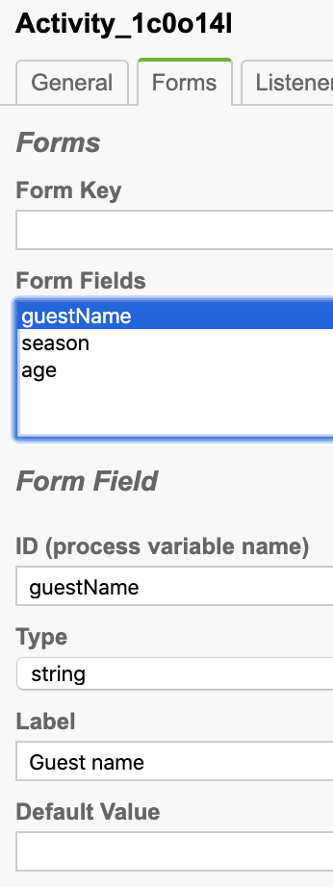
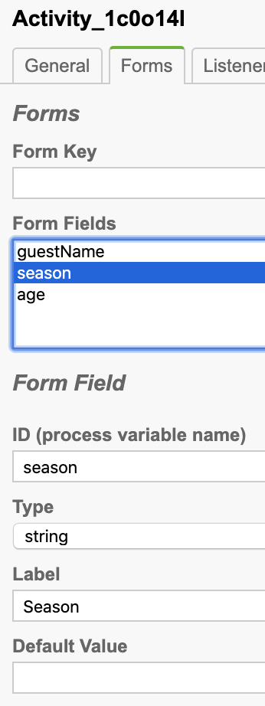
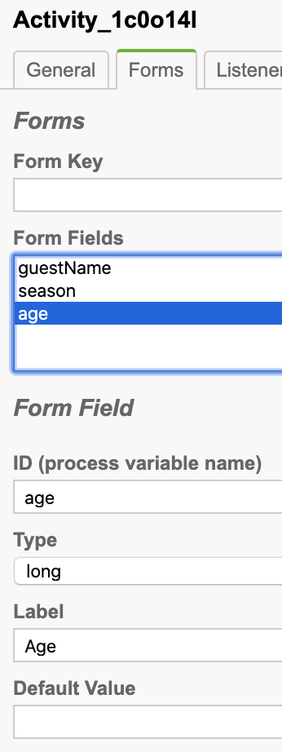
Task form

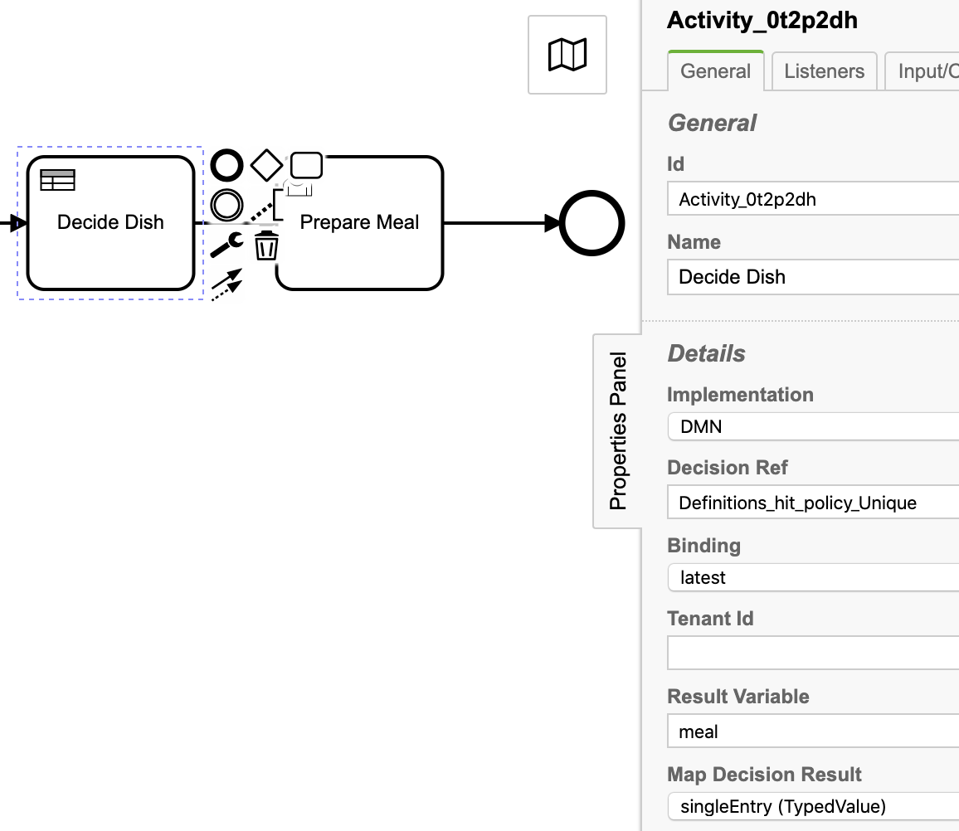
3.2. Business rule task: Decide Dish

Id: Activity_1c0o14l
Name: Guest Registration
Implementation: DMN
Decision Ref: Definitions_hit_policy_Unique
Binding: latest
Result Variable: meal
Map Decision Result: singleEntry (TypedValue)

3.3. User task: Prepare Meal
Id: Activity_1tl0gtc
Name: Prepare Meal
Assignee: demo

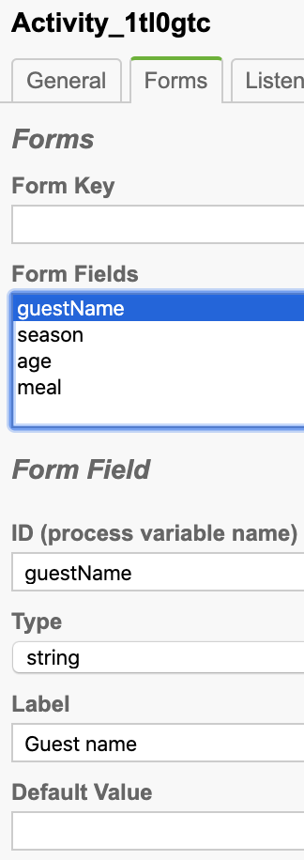
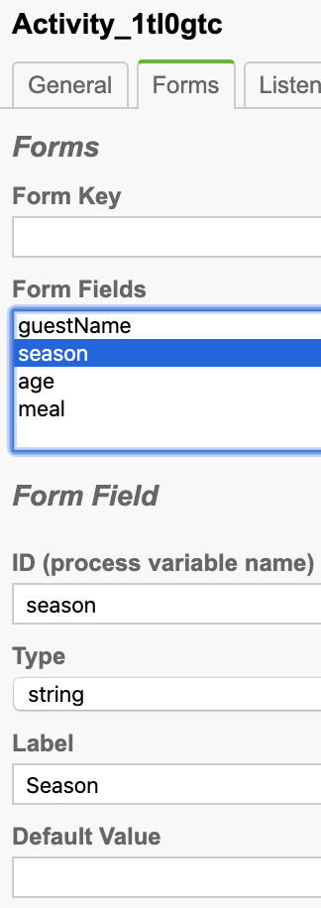
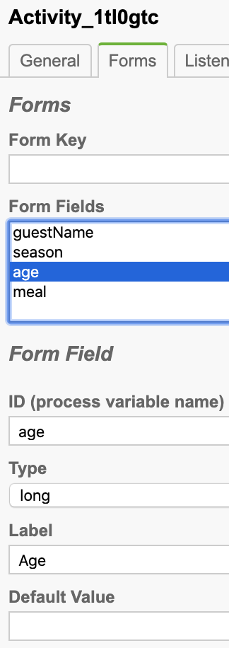
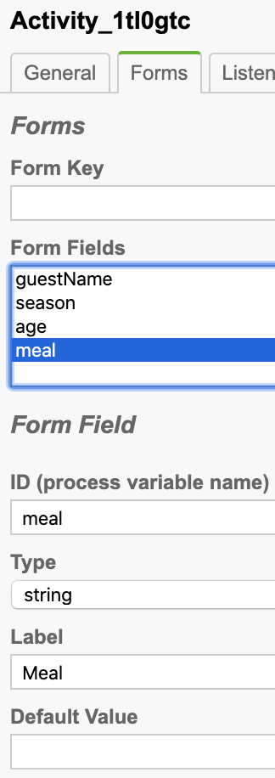
Task form
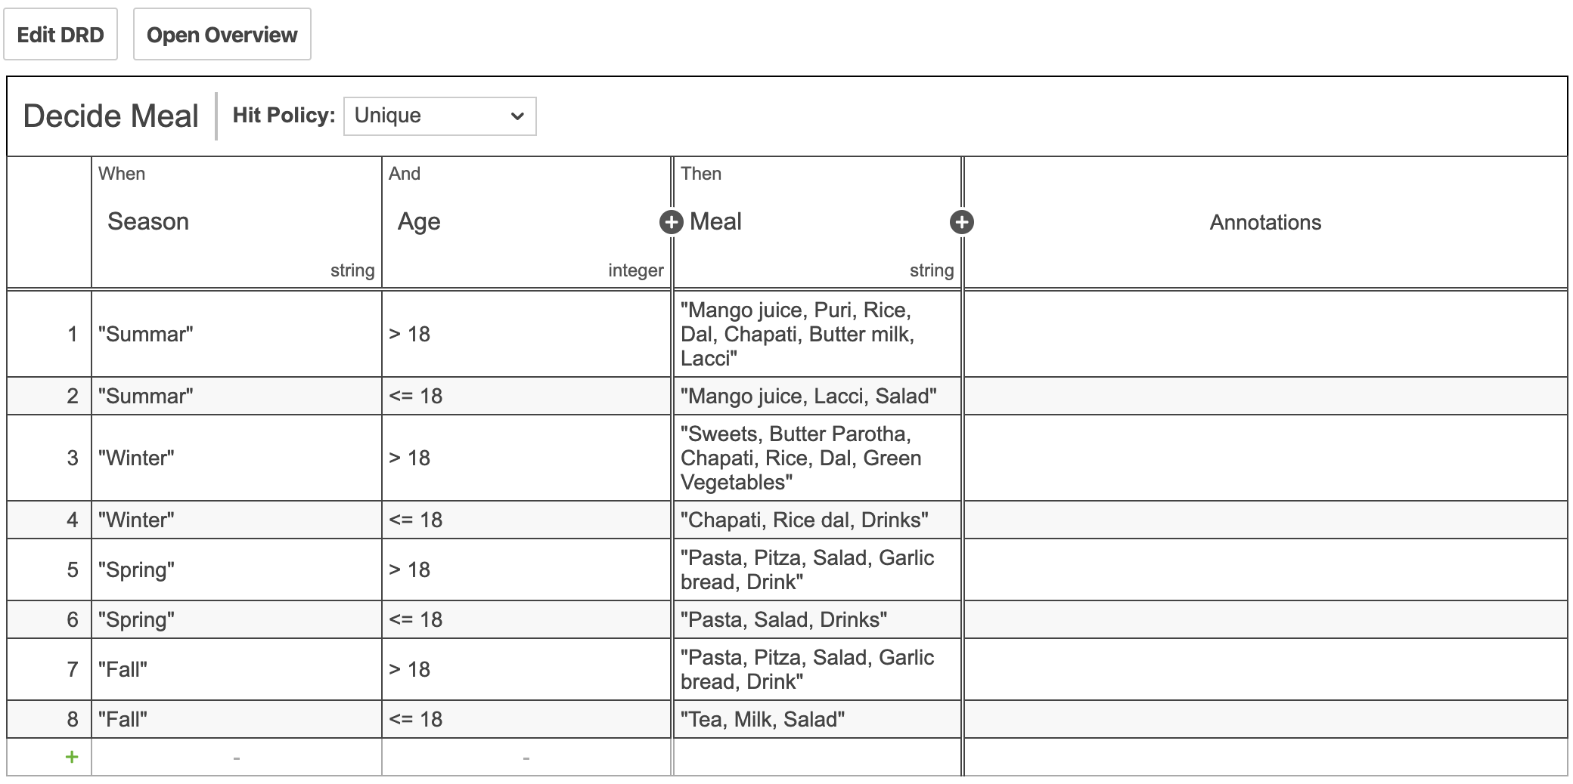
4. Decision table:

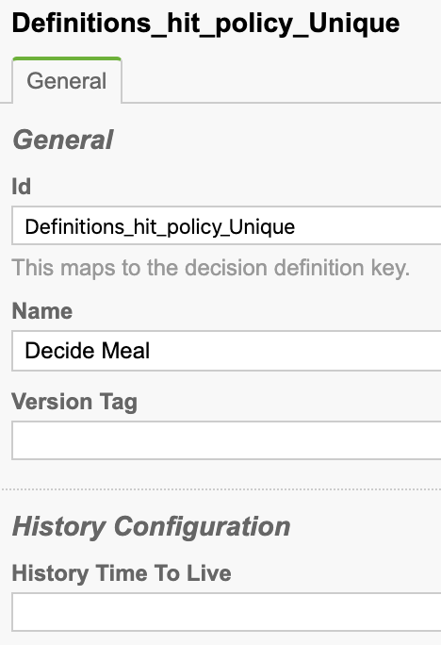
Properties:

Id: Definitions_hit_policy_Unique
Name: Decide Meal

5. Deploy process definition and decision table.

6. Testing the process definition and DMN

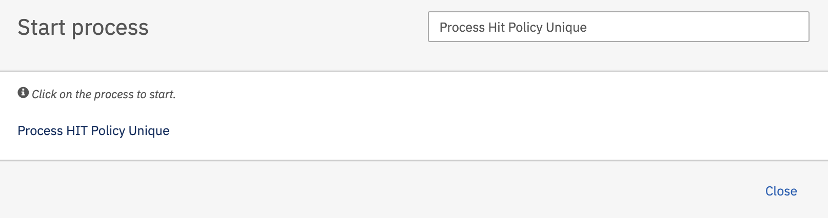
Start the process definition
Hit Process HIR Policy Unique and press Start button to start process.

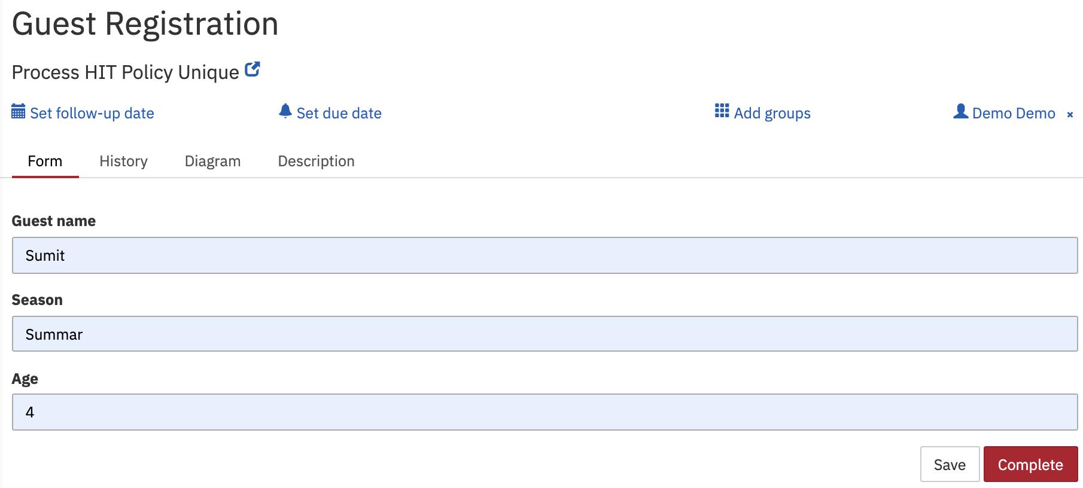
As per process definition, user task Guest Registration will get created.

Fill-up the task form and press Complete button and then as per process definition business rule task get executed and will produce single output based on provided data by task and same output result can be viewed on newly created user task Prepare Meal.

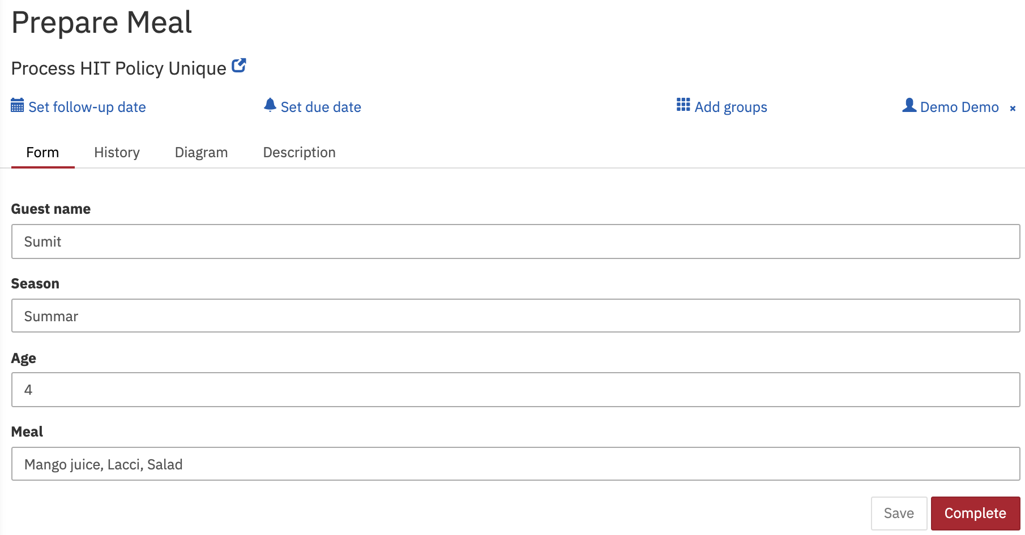
It can be seen that business rule task has invoked decision table and produces output Meal = Mango juice, Lacci, Salad

Note: In decision table if you have two rules satisfied with provided input data then error will be thrown as below
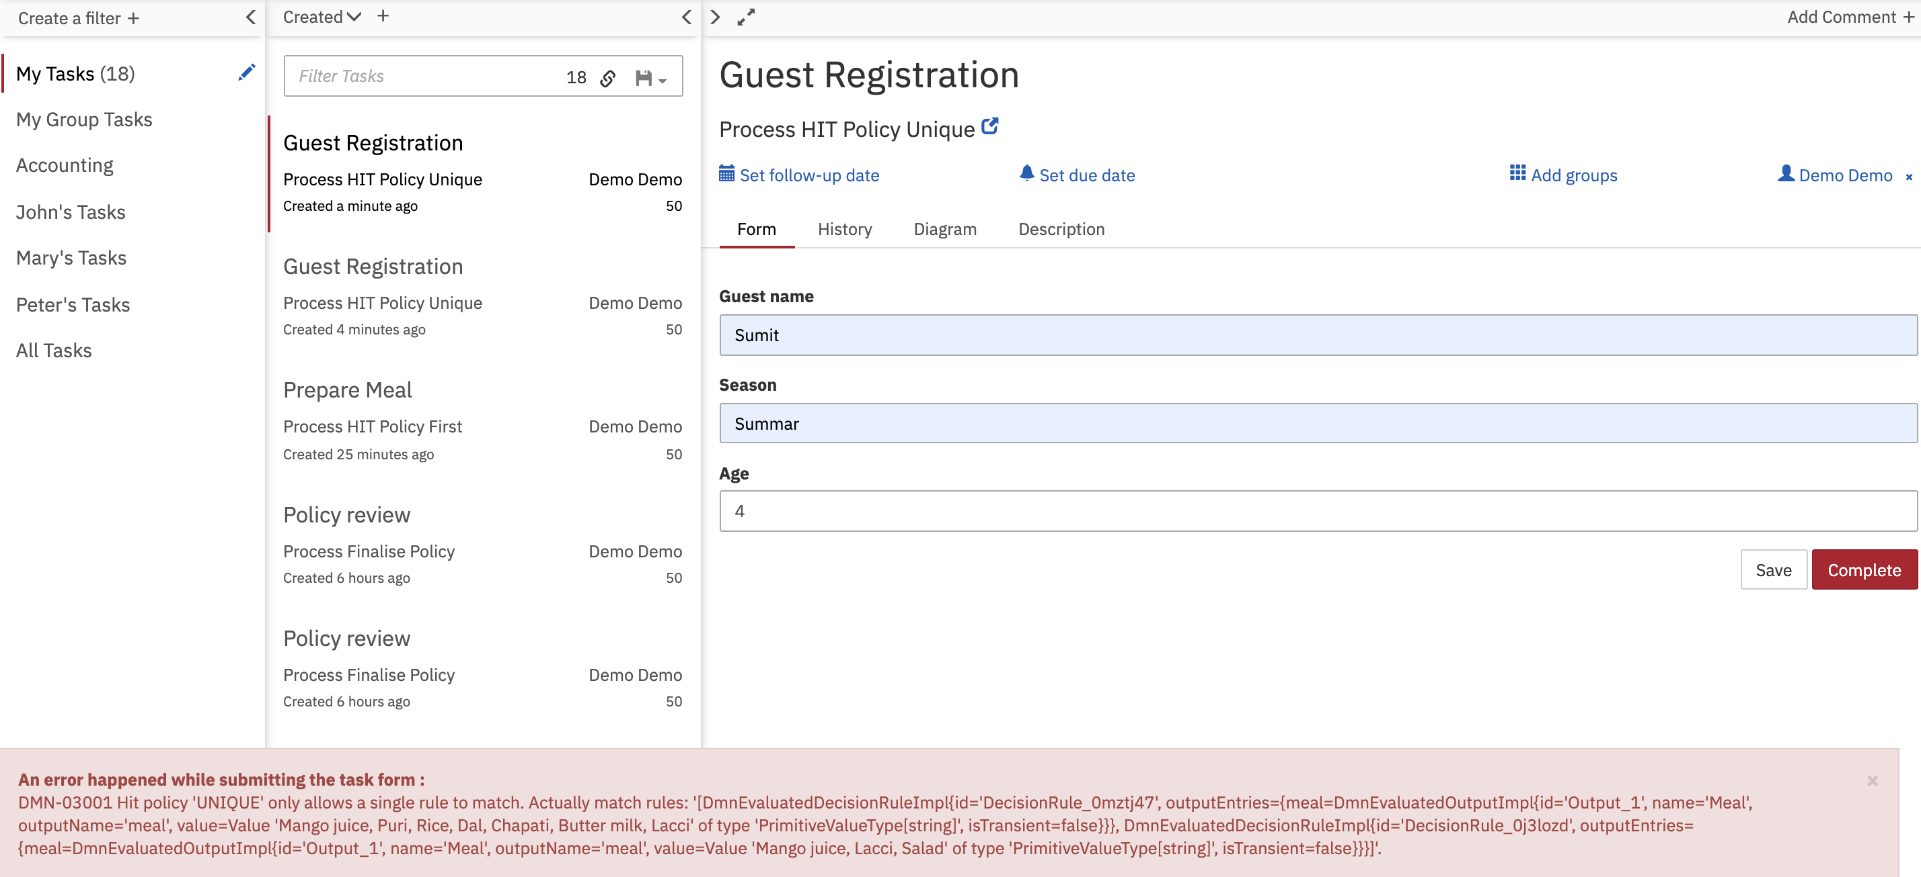

Tomcat console error logs

14-Sep-2020 18:31:05.184 WARNING [http-nio-8080-exec-1] org.camunda.commons.logging.BaseLogger.logWarn ENGINE-REST-HTTP500 org.camunda.bpm.dmn.engine.impl.hitpolicy.DmnHitPolicyException: DMN-03001 Hit policy 'UNIQUE' only allows a single rule to match. Actually match rules: '[DmnEvaluatedDecisionRuleImpl{id='DecisionRule_0mztj47', outputEntries={meal=DmnEvaluatedOutputImpl{id='Output_1', name='Meal', outputName='meal', value=Value 'Mango juice, Puri, Rice, Dal, Chapati, Butter milk, Lacci' of type 'PrimitiveValueType[string]', isTransient=false}}}, DmnEvaluatedDecisionRuleImpl{id='DecisionRule_0j3lozd', outputEntries={meal=DmnEvaluatedOutputImpl{id='Output_1', name='Meal', outputName='meal', value=Value 'Mango juice, Lacci, Salad' of type 'PrimitiveValueType[string]', isTransient=false}}}]'.

